Music Playlist Generator – Project Report
Made By:-
Soumya Gupta
25BAI10628
Project Title
Music Playlist Generator (Command-Line Based)

Overview / Abstract
This project is a simple yet practical attempt to solve a common problem—organizing music in a meaningful way. The Music Playlist Generator allows users to store songs along with details like artist, mood, and favorite status, and then generate playlists based on how they feel. Instead of just listing songs, the system adds a personal touch by filtering and shuffling them to create a better listening experience. Built using Python, the project focuses on applying basic programming concepts like file handling and modular functions in a real-world scenario. It is lightweight, easy to use, and reflects how small ideas can turn into useful tools.

Key Features
- Add songs with relevant details like name, artist, mood, and favorite tag
- View the entire music collection in an organized way
- Generate playlists based on mood (e.g., happy, sad, chill)
- Shuffle songs to avoid repetition and keep it interesting
- Delete songs that are no longer needed
- Quickly access favorite songs

Functional Requirements
- The system should allow users to enter and store song details
- It should display songs clearly when requested
- It should filter songs based on mood input
- It should shuffle playlists automatically
- It should allow removal of songs from the collection
- It should identify and show favorite songs separately

Non-Functional Requirements
- The system should be simple enough for any beginner to use
- It should respond quickly without unnecessary delays
- It should handle invalid inputs without crashing
- The code should be clean and easy to understand
- It should work on basic systems without special requirements

System Architecture
The project follows a straightforward structure. The user interacts with the system through a command-line menu, which acts as the input layer. Behind the scenes, the processing layer handles all logic like filtering songs, shuffling playlists, and managing data. The storage layer uses a text file to save songs so that data is not lost after the program ends. Finally, the output layer displays the results in a readable format. This simple architecture keeps everything easy to manage while still being effective.

Design Diagrams – Text Description
Although no graphical diagram is used, the design can be understood as a step-by-step flow. The user selects an option from the menu, the program calls the corresponding function, performs the required task, and then shows the output. Each function acts like a small independent unit, making the system modular and easier to understand.

Workflow Description
The workflow begins when the program starts and displays a menu. The user chooses what they want to do—add a song, view songs, generate a playlist, etc. Based on this choice, the program performs the action. For example, while generating a playlist, it reads stored songs, filters them by mood, shuffles them, and displays the result. This cycle continues until the user decides to exit. The process is repetitive but smooth and intuitive.

Sequence Description
The sequence of actions in the system is simple and logical. First, the user gives input. The program then processes this input by calling the required function. That function may read or update the file, depending on the task. After processing, the result is shown to the user. For example, in playlist generation: input → processing → filtering → shuffling → output. This clear sequence ensures the program works reliably.

Component / Module Description
The project is divided into smaller functions, each handling a specific task. The add_song() function is used to add new songs. The view_songs() function displays all stored songs. The generate_playlist() function creates mood-based playlists and shuffles them. The delete_song() function removes songs. The show_favorites() function highlights favorite tracks. Supporting functions like load_songs() and save_songs() manage file operations. This modular approach makes the code easier to manage and improve.

Design Decisions & Rationale
The main focus while designing this project was simplicity. A command-line interface was chosen instead of a graphical one to keep the implementation easy and focused on logic. A text file was used for storage to avoid the complexity of databases. Functions were used to break down the program into smaller parts, making it more readable and organized. Features like shuffle and favorites were added to make the application feel more practical and user-friendly.

Implementation Details
The entire project is implemented in Python. File handling is used to store song data permanently, while lists are used to temporarily manage songs during execution. Basic programming constructs like loops and conditionals control the flow of the program. The code is structured into functions, which helps in avoiding repetition and improves clarity. Overall, the implementation is simple but demonstrates how core concepts can be applied effectively.

Testing Approach
Testing was done by trying different user inputs and scenarios. Each function was tested separately to ensure it works correctly. File operations were checked multiple times to confirm that data is stored and retrieved properly. Special attention was given to invalid inputs, such as wrong menu choices, to ensure the program does not crash. Playlist generation was tested with different moods to verify correct filtering.

Challenges Faced
One of the main challenges was handling file data properly, especially maintaining a consistent format while reading and writing. Another difficulty was managing user errors without breaking the program. At times, the logic for filtering and shuffling needed refinement to work smoothly. These challenges helped in improving problem-solving skills and understanding the importance of testing.

Learnings & Key Takeaways
This project helped in connecting theory with practical application. It improved my understanding of file handling, functions, and program structure. I also learned how important it is to write clean and organized code. Debugging errors and fixing them step by step was a valuable experience. Overall, the project showed how even simple ideas can be turned into useful programs.

Future Enhancements
In the future, this project can be expanded by adding a search feature to quickly find songs. Support for multiple moods per song can make playlists more flexible. A graphical user interface can make the program more interactive and visually appealing. Integration with online music platforms could also make it more advanced and realistic.

Commit History
The development of this project was done step-by-step rather than all at once. Initially, the basic structure and menu system were created. Then, features like adding and viewing songs were implemented. Later, playlist generation and shuffle functionality were added. After that, delete and favorite features were introduced. Finally, the code was cleaned up and improved. This gradual approach reflects a proper development process and better understanding of version control.

References
- Python Official Documentation – for understanding file handling and basic syntax
- Automate the Boring Stuff with Python by Al Sweigart – for practical Python concepts
- GeeksforGeeks – for learning logic and implementation examples
- Stack Overflow – for debugging and problem-solving help
- Class notes and personal coding practice

Screenshots
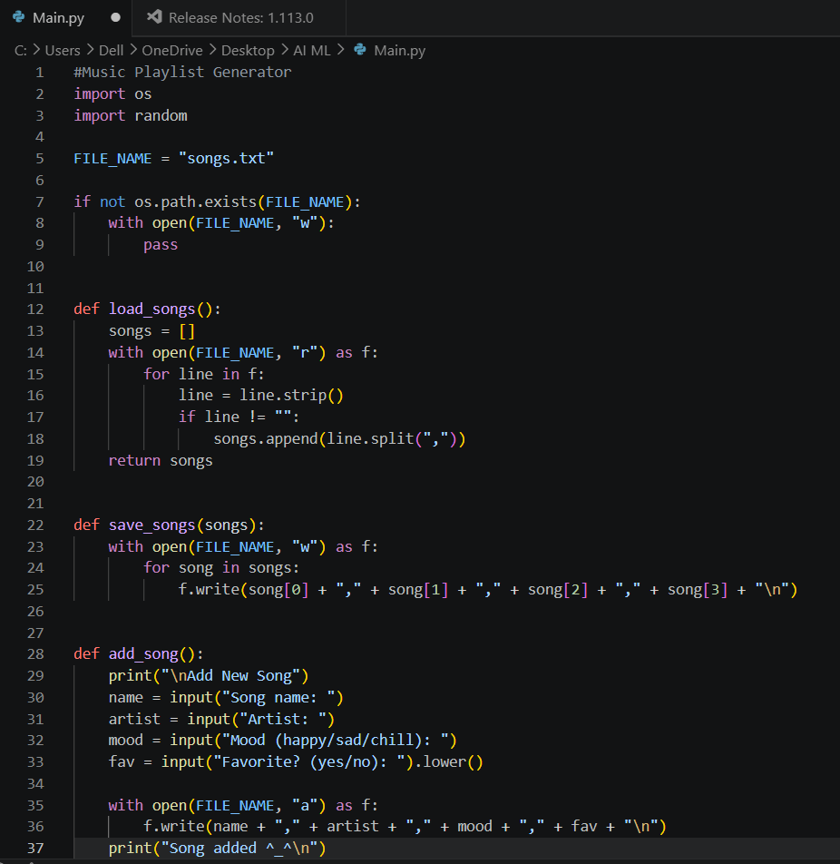

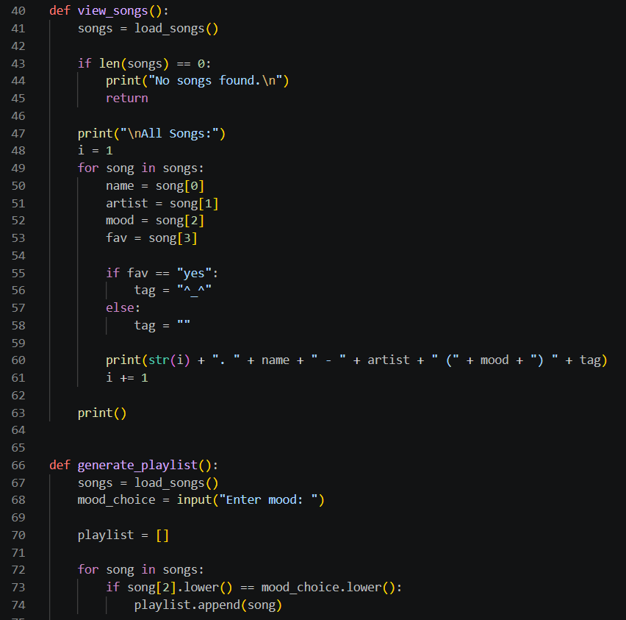

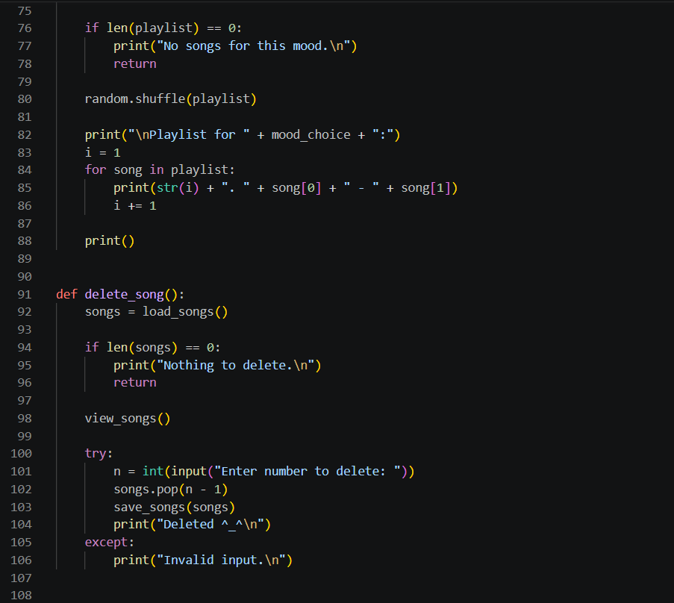

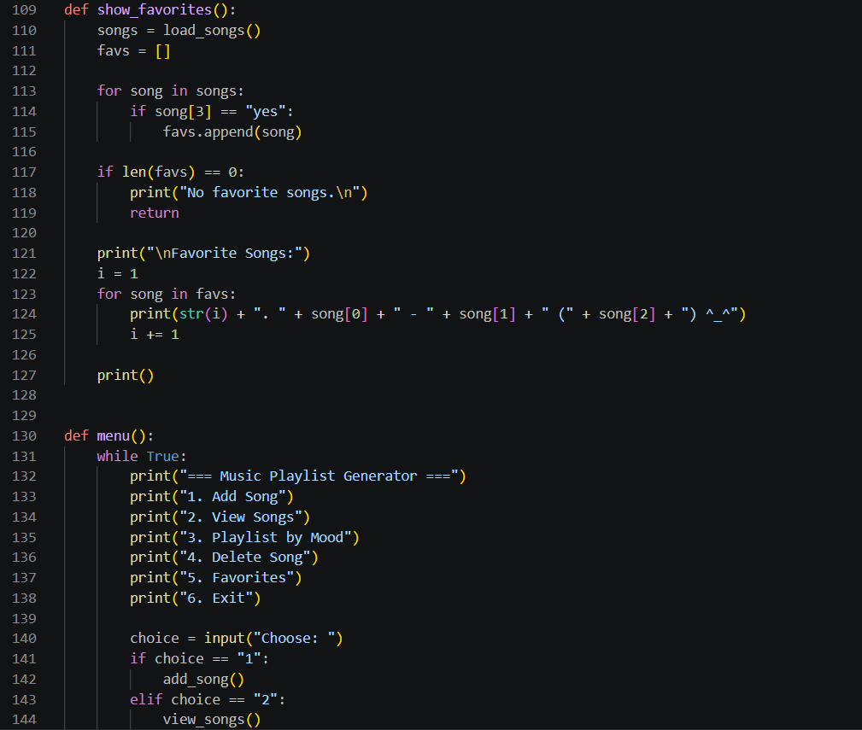

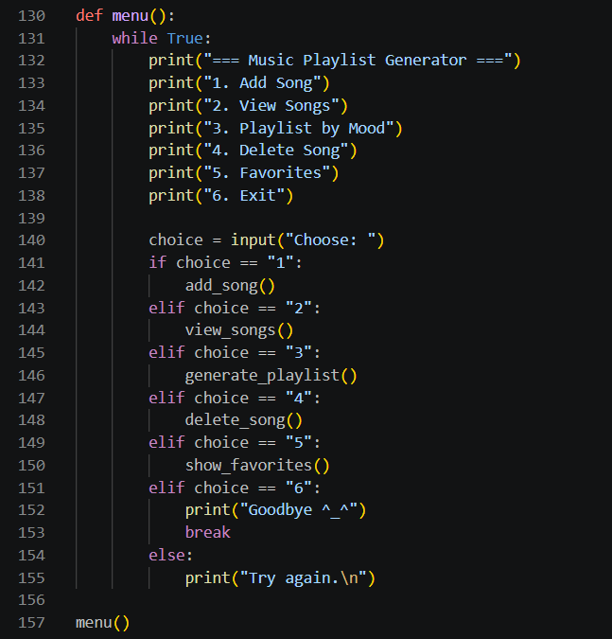

Output:-

